Current Children and Youth Cabinet Indicators  - Birth to women with fewer than 12 years of education  - Teen births  - Domestic violence  - Mothers beginning prenatal care in the first trimester  - Early childhood staff with bachelor’s degrees  - Children in poverty  - Children who are homeless  - Children in supportive neighborhoods  - Children whose kindergarten entry assessment scores show they are ready for school  - Children who are read to by their parents or relative caregivers  - Children who are maltreated  - Children with a medical home  - Children with health insurance | Florida’s First 1000 Days Priorities  Safety:  - Expanded access to trauma-informed care and courts  - Trauma-informed competency among those who deal with children and their families  Nurture/Education:  - Quality for child care and expanded access  - Money for home visitation and community-based support  - Expanded parental support through Help Me Grow  - Collection of relevant data to measure child/family wellbeing  Health Care:  - Restoration of KidCare outreach money  - Training mental health counselors on early childhood mental health issues  - Expanded access to dental care for children 0-3  - Rewriting mental health bill to include parental and caregiver anxiety and depression, pregnancy mental health issues and early childhood mental health  - Maintain or expand prenatal Medicaid to 185% of poverty  - Remove five-year ban for immigrant women to receive prenatal care  Security:  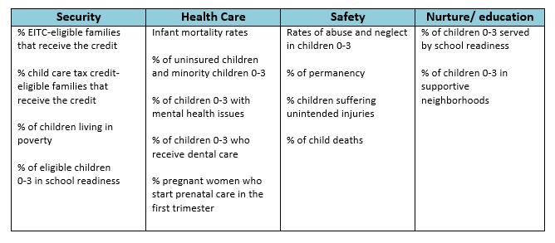  - Increase funding for Earned Income Tax Credit (EITC) assistance. | 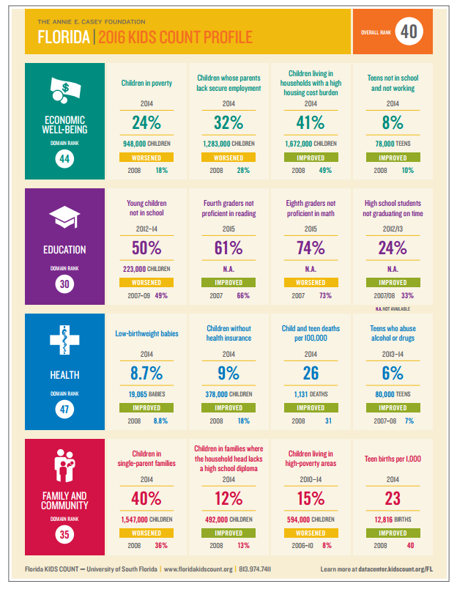
Noreen Dollard, Department of Child and Family Studies at Louis de la Parte Florida Mental Health Institute at USF and Florida KIDS COUNT

- Healthy birth weights
- Poverty
- Kids under 5 in school
- Parent education level
- Kindergarten readiness
Next Generation, California Study on Indicators that Predict a Child’s Life Outcomes

- poverty (child poverty and total poverty rates)
- educational attainment (rate of 4-year degree holders and those without a high school diploma)
- health (low birth-weight and asthma hospitalizations)
- family structure (rate of single mother households)

